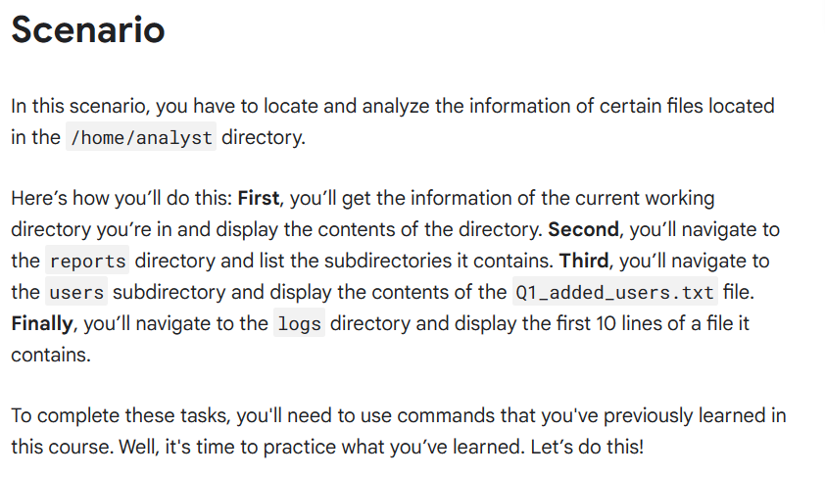

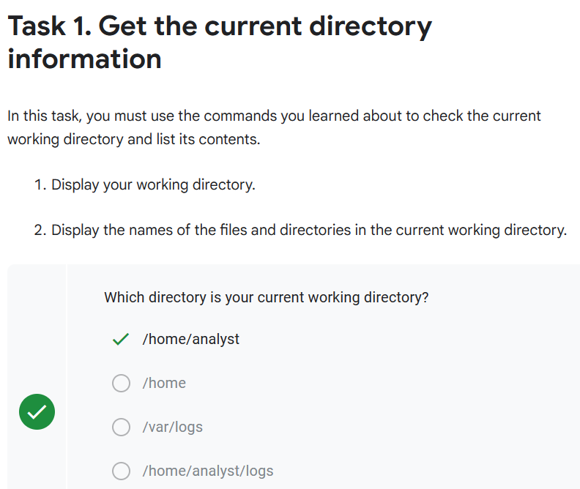

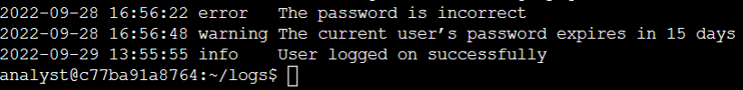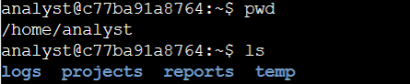

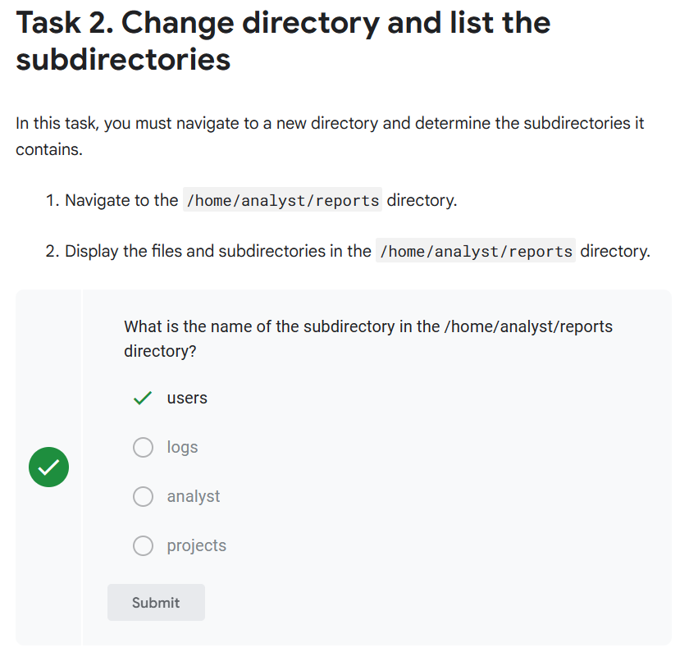

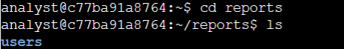

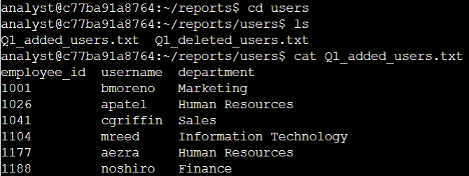

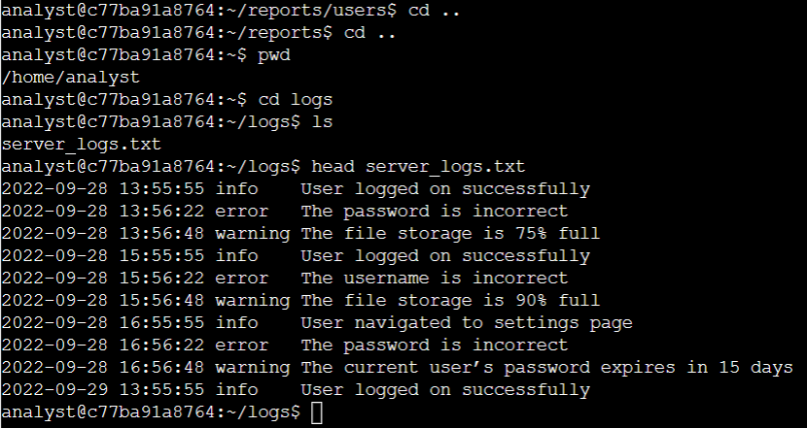

**Activity completed Using Linux bash shell**

